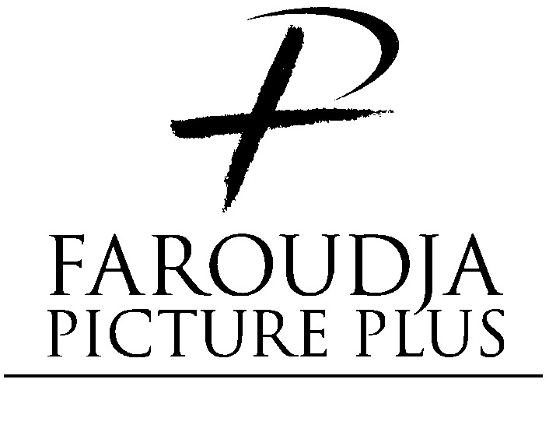

RP5800 Rear Projection System

HDTV/DTV Multi-Scan System
With Picture PlusTM Technology

Installation and Operation Instructions

Table of Contents

Introduction…………………………………………..…….3

Unpacking………………………………………………….4

Connecting Sources………………………………………6

Operation and Setup…………………………………..….7

Warranty…………………………………………….…….…12

Copyright ©1998 by Faroudja Laboratories Inc.

No part of this document may be copied, photocopied, reproduced, translated, or reproduced to any electronic medium or machine readable form without prior consent, in writing, from Faroudja Laboratories, Inc. The Faroudja name, logo and Picture Plus are registered trademarks of Faroudja, Inc. Specifications subject to change.

The Faroudja Laboratories RP5800 is covered by the following United States patents: 4,030,121, 4,179,705, 4,240,105, 4,262,304, 4,847, 681, 4,864,389, 4,876,596, 4,893,176, 4,916,526, 4,967,271, 4,982,280, 4,989,090, 5,014,119, 5,025,312, 5,159,451, 5,237,414.

All Rights Reserved.

Made in USA

Thank you for purchasing the RP5800 Rear Screen Projection System. The RP5800 was designed to provide optimum image quality for all types of sources, from DVDs to HDTV and computers

To properly display high resolution images on a rear screen display, high performance characteristics are essential at each stage of the process. If not, the picture will have no greater resolution than NTSC.
Signal Processing
Optics
Screen

Rear Screen System Main Stages

There are three main stages in providing the optimum high resolution image:

Signal processing: how the incoming signal is processed and controlled. This also includes operator controls, picture alignment and system diagnostics functions.

Optics: the quality and performance of the Red, Green, and Blue tubes, mirror and lenses.

Screen: screen resolution, dispersion of light and the ability to handle high ambient light conditions.

The Faroudja RP5800 was designed to provide true state of the art performance in every step of the imaging process. A no-compromise approach was taken for each stage of the designing and building process to insure years of trouble free, high quality home theater viewing.

Unpacking

The RP5800 ships in two boxes to make shipping and handling easier.

Due to the size of the unit when assembled, it is important to determine in advance where the assembly should take place. Although the unit will fit through standard residential door frames, the cartons themselves are wider than most door frames. We suggest that the entry doors to the installation site be measured prior to delivery and unpacking to determine if any of the components must first be unpacked, and then carried into the viewing room location. To avoid damage to the unit we do recommend that the unit be unpacked and assembled in the room where it will be used.

It should also be noted that for safety and to assure precise placement of the heavy parts of the unit, the assembly requires at least two people, preferably three, each able to lift a sixty pound object. For some of the steps, additional help is desirable.

We recommend that the assembly be done in a clean, dust free area, as the unit’s mirror and screen will be exposed to open air during the assembly process.

Before proceeding, note that the two shipping cartons are different sizes. The smaller, heavier carton contains the base unit, which includes the projector chassis. The larger box contains the mirror and screen unit.

Cut the retaining straps and remove the wood top cover. Lift the cardboard sleeve over the cabinet. Lift the cabinet off the pallet and remove the shrink-wrap. Carefully lift/roll the bottom cabinet off the pallet.

The mirror assembly ships inside the top portion of the cabinet. Follow the drawing below for removing the screen frame and mirror.

SCREEN MUST BE HANDLED WITH CARE. DO NOT TOUCH SCREEN SURFACE AND DO NOT DROP SCREEN FRAME.

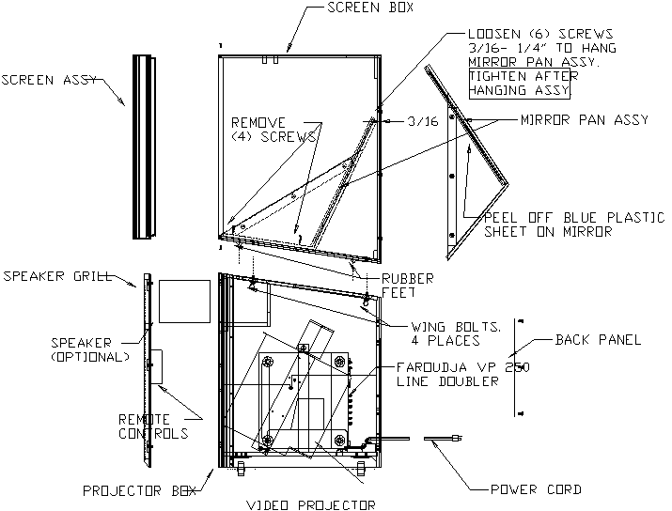

Remove the retaining screws holding the mirror assembly in place. Carefully remove it and set in a safe place. With these parts removed the top portion of the cabinet is easier to move. It is also 29” deep to fit through most door openings.

Position the bottom portion of the cabinet on a flat surface. Lift the top portion and carefully set it on top using the rubber guides for proper positioning. Securely tighten the wing bolts. Hang the mirror assemble simply by sliding it on to the existing bolts and tighten down.

THE TOP PORTION OF THE MIRROR ASSEMBLY FITS INSIDE THE TOP CABINET

Connecting Sources
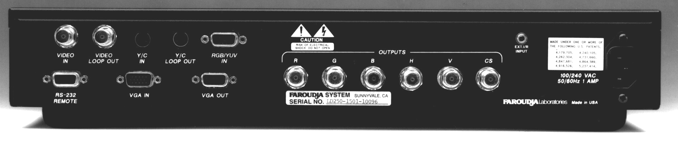
1
2
3
4
5
6
7
8
9
10
11

RP5800 input panel
(It is mounted vertically in the rear cabinet)

To connect sources, remove the small cover located on the left side on the rear of the cabinet. Feed the source cables through the access opening and install them to the appropriate connector.

All inputs except the VGA input are processed by the Faroudja built-in processing to convert all signals to high resolution 480 Progressive signals. Sources connected to the VGA input are “Passed-Through” without any processing straight to the projector. This insures that the high scan rate sources such as HDTV and computer signals are properly displayed in their “native” scan rates to maintain maximum image quality.

1. Composite connection. Recommended sources:
VHS
Cable
Laserdisc

2. Composite Video Loop Out. Allows for looping Composite signal to another device. The device must have 75ohm termination.

3. S-Video Connection. Recommended sources:
DVD
Digital Satellite
Hi-8
4. S-Video Loop-Out. Allows for looping S-Video signal to another device.

5. Component Video Connection. A four wire Female BNC to D15 connector is provided to allow connection of high bandwidth component video and RGB sources. Recommended source:
DVD
BetaSP
Broadcast and document cameras

6. RS232 Connection. The connected cable provides two way communications between the input processor and the projector. DO NOT DISCONNECT.

7. VGA Connection. Allows for connection of high scan-rate sources. Recommended sources:
HDTV (RGBHV)
Computer (RGBHV)

8. VGA Out. Allows for connecting a second high scan rate display device. It outputs the same signal as is sent to the RP5800 projector. (Note: the second display device must be capable of a minimum horizontal scan rate of 31.5kHz)

9. RGB Output. Outputs the high resolution signals to the RP5800 projector. DO NOT DISCONNECT

10. External Infrared Sensor. The receiver for the Infrared remote control connects here. DO NOT DISCONNECT.

11. AC Power Connection. DO NOT DISCONNECT.

Power

The RP5800 draws approximately 335 watts at normal operating conditions. Make sure the AC power line provides a clean line, not shared by other equipment such as air conditioners. To avoid ground loops, the source equipment should be on the same line or at least have the same phase as the RP5800. A power conditioner is recommended.

Operation and Setup

The RP5800 is aligned completely for three aspect ratios from the internal line processor prior to shipping. However, some fine tuning of the settings will be needed to get optimum performance. Please refer to the Setup section for a complete listing of the steps required.

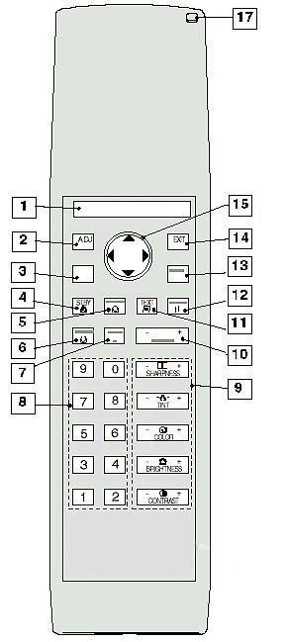

The RP5800 ships with two remote controls. The larger remote is a “Service” remote and used for projector setup and adjustment. The smaller remote is the “User” remote designed for a simplified user interface for day-to-day operation. Explanation on use of the service remote can be found in the separate Installation Manual. The User remote will be detailed here.
Service Remote

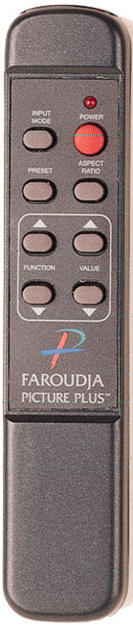
Remote Control Use
1
2
3
4
5
6
7
8

- Toggles Power On/Off
- Toggles between the preset Aspect Ratios
- Value up increase selected function
- Value down decreases selected function
- Selects the different inputs
- Toggles through Factory and Customer presets
- Toggle up through the available Functions
- Toggle down through the available Functions

The control software is set up to provide as simple an interface between the processor and the projector as possible. The easiest method to control picture and aspect ratio is to switch between them using the Preset select button. The control software can be summarized as follows:

- Pressing the Preset button toggles between the four custom and Factor presets PLUS the stored aspect ratio for each preset.

- Pressing the Aspect Ratio button selects the different aspect ratios while the picture adjustment levels stay the same.

This method has been designed since changing Aspect Ratio usually requires different levels so this allows the use of one button instead of two (Aspect ratio AND Preset).

Turning RP5800 on: Simply press the Power button on the User Remote to toggle the power on and off. The unit will recall all of the last settings and input from when it was last used.

PLEASE WAIT FIVE SECONDS BETWEEN TURNING UNIT ON AND OFF TO ALLOW TIME FOR THE HIGH CURRENT POWER SUPPLY TO RESET

Selecting Inputs: Press the Input button on the User remote to toggle between the different inputs. As each input is selected the RP5800 automatically recalls the last used settings.

- Composite Video
- S-Video
- Component Video
- RGB Video
- VGA (HDTV/Computer)

Preset Selection: Each input offers four presets plus Factory that can be recalled by the remote control. Each preset stores the picture adjustment settings and the Aspect Ratio. Simply press the Preset button on the remote to toggle through the different presets. The RP5800 ships from the factory with all presets set to the Factory preset setting with the Aspect Ratio stored as follows:

Preset 1 = Aspect Ratio 1
Preset 2 = Aspect Ratio 2
Preset 3 = Aspect Ratio 3
Preset 4 = Open
Factory

Once the RP5800 is connected to all sources, the picture level adjustments need to be made to perfectly match it to the sources.

Preset Storing: There is a simple three step procedure for storing custom presets in the RP5800:

1. Select the appropriate Aspect Ratio
2. Adjust image for best results.
3. Using the Function key, select Presets on the On-Screen menu.
4. Use the Value key to select one of the presets. The settings are stored when either the Function button is pressed up or down or simply wait and they will be stored when the On-Screen-Display turns off.

Factory Preset Setup

- Press the Preset button on the User remote until Factory is listed on the On-Screen-Display.
- Select the correct Aspect Ratio.
- Using the Function key, select Presets on the On-Screen menu.
- Use the Value key to select one of the presets. The settings are stored when either the Function button is pressed up or down or simply wait and they will be stored when the On-Screen-Display turns off.

Aspect Ratio

The RP5800 is set for three Aspect Ratios from the factory for standard video sources. Depending on the source simply select the correct screen shape for proper image shape (called Geometry). Selection can be made two ways:

- Pressing the Preset button. This will toggle through the different presets that include the Aspect Ratio and picture settings.
- Pressing the Aspect Ratio button. Toggles though the different Aspect Ratios while the picture settings stay the same.
16:9 Anamorphic
4:3 Reduced
4:3 Letterbox

Aspect Ratio 1 - 4:3 Letter box. This setting is used with any Letterbox source from sources such as DVD, Laserdisc, Satellite and VHS tapes. The top and bottom of the image is over-scanning the top and bottom of the screen. If this Aspect Ratio is used with standard full screen 4:3 sources the image will appear as if it was “Zoomed” in towards the center.

Aspect Ratio 2 – 16:9 Anamorphic. This is used with Anamorphic DVDs only. This is the format/Aspect Ratio combination that yields the highest quality performance. (The DVD player must be set up to output the anamorphic information. See the DVD player’s manual for instructions.)

Aspect Ratio 3 - 4:3 Reduced. This setting is ideal when viewing standard 4:3 sources where the full image should be seen such as with news and sports.
The 4:3 Reduced setting puts a large amount of energy on a small area of the RP5800 CRT tubes. Contrast should not be set any higher than 60% of maximum to prevent CRT damage and image burn-in. Image burn-in is not covered by warranty.

Do not let still images remain on the screen for long periods of time (such as text with video games). The bright areas of the still image can cause image burn-in.

If a new Aspect Ratio is desired, see the Installation manual for details. It is recommended that your Faroudja dealer be contacted for assistance

Picture Adjustment

Having the RP5800 correctly installed and adjusted is key to experiencing the full potential of high resolution images. To properly align the RP5800, a test signal needs to be used to establish the correct reference settings. We recommend using a test pattern DVD, laserdisc or a signal generator to align your system. The Factory Presets are set for optimum performance using broadcast industry standards. They can be used as a reference and recalled if controls get misalign.
The RP5800 is pre-aligned at the factory. However, due to minor changes as a result of shipping and variations in your home theater setup, a qualified Faroudja dealer should fine-tune the RP5800 when first installed.

Brightness - The Brightness control adjusts the black levels in the image. The level should be adjusted so that the color black is achieved (not gray) yet still able to see faint details in the shadows. It is best to use a test pattern know as a PLUGE to set the levels.

Contrast - This control adjusts the level of white in the image. Using a well-lit image, adjust the contrast for the brightest image but not so bright that white areas start to turn green or cause blooming. Blooming is seen as bright areas of the picture smearing off to the right. It is best to use a test pattern know as a PLUGE to set the levels. Contrast and brightness interact with each other so it is best to recheck both.

Color - This adjusts the amount of color in the image. Adjust to individual taste. There is an AGC (Automatic Gain Control) circuit that adjusts the color level automatically to maintain optimum color settings using the customer’s adjusted setting as a reference. It is best to use a test pattern known as SMPTE color bars with a blue filter to properly set the levels.

Tint - This adjusts the color phase seen as the range from green to magenta. There is an APC (Automatic Phase Control) circuit that maintains proper phase. This setting is best left in the preset position. It is best to use a test pattern known as SMPTE color bars with a blue filter to properly set the levels. Tint control is not available when using component video sources or the PAL (European standard) format.

Detail Settings

The RP5800 offers a patented Detail circuit that provides optimum picture detail without introducing “ringing” artifacts for both the horizontal and vertical edges. This is very helpful with low quality sources such as VHS tapes. The level should be set so there is the maximum amount of edge detail without excessive harshness.

The Detail control can also help to reduce enhancement artifacts found in high quality sources such as DVDs and Laserdiscs. These formats can have excessive enhancement ringing recorded in the movie (this can be seen as white halos along dark edges in the movie scene). The detail level can be reduced to limit the visibility of the ringing.

However, for the most part, the control should be left in the preset setting. If the Detail level must be turned way up to perceive any details it is a good chance there are other factors causing a soft picture such as the projector becoming out of focus. Contact the dealer for assistance.

Detail - This adjusts the amount of large and small edge details in the image. The level should be set where there is the maximum amount of edge detail without excessive harshness. For most sources, this should be left in the preset setting(between 6-8).

When the VGA(HDTV/Computer) input is selected, the signal is “passed-through” to the projector bypassing the built-in line processor. This maintains optimum signal performance. Controls for Color, Tint and Detail are not available.

Specifications

Screen 58” Wide,16:9 Aspect Ratio, High Contrast Black Stripe

Cabinet MDF, Single Front Surface Mirror Assembly

Lenses 7” High Definition, Liquid Coupled, Color Corrected for Sharp Corner-to-Corner Focus

Scanning Frequency 31.5kHz – 69kHz Horizontal, 37Hz – 210Hz Vertical

Resolution Computer: Up to 1280X1024 Progressive/60Hz
HDTV: 480P, 720P, 1080I, 1080P

Line Processor 15.75kHz interlaced to: 480P/60Hz(NTSC)
580P/60Hz(PAL)

Bandwidth 75mHz

Convergence System 25 Zone Point Convergence, 38 Preset Memories

Aspect Ratio Variable, 4 Aspect Ratio Memories Per Scan Rate

New Scan Rate Recognition Linear Digital Interpolation

Auto-Convergence
Auto Geometry IRIS CCD-camera system

Color Temperature 3200K, 4900K, 6500K, 9600K, Custom. Gain/Cutoff adjust for Red, Blue and Green

Inputs Video, S-Video, Component (Y, Cr, Cb), RGB
Computer / HDTV (D15)

Power 120/220VAC 335wts max.

Shipping Weight 573lbs.

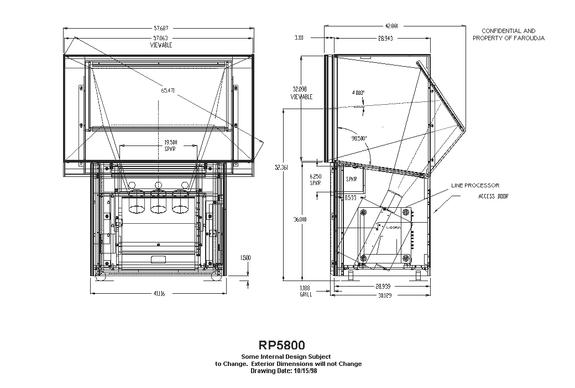
WARRANTY INFORMATION

All FAROUDJA Laboratories products are warranted to the original purchase against defective materials and workmanship under normal use and service for a period of one (1) year from the date of shipment. This warranty shall be of no force and effects if modifications have been made by the purchaser or its agents or employees or if damage results from connecting the product to incompatible equipment or power. CRT phosphor damage or burn-in caused by miss-use or static images is NOT covered. This warranty will also be void if the product is not returned to FAROUDJA Laboratories in the original shipping container.

The purchaser's sole remedy with respect to the breach of this warranty is for the selling distributor to repair or replace, at its option, those products which the selling distributor determines to have breached this warranty within the specified period.

Any claims under this warranty should be made by telephone or in writing to the selling distributor or FAROUDJA Laboratories. No products should be returned to the selling distributor or to FAROUDJA Laboratories without its prior consent, and then, only with freight prepaid. FAROUDJA Laboratories will prepay the return shipment.

Specifications and price change privileges are reserved.

THIS WARRANTY IS IN LIEU OF ALL OTHER WARRANTIES EXPRESSED OR IMPLIED INCLUDING, WITHOUT LIMITATIONS, ANY IMPLIED WARRANTY FOR MERCHANTABILITY OR FITNESS FOR A PARTICULAR PURPOSE.

FAROUDJA Laboratories 750 Palomar Ave., Sunnyvale, California 94086
Tel: 408-735-1492 Fax:408-735-8571

